***Data Analytics Report***

**MARKET BASKET ANALYSIS - Electronidex**

|  |  |  |  |
| --- | --- | --- | --- |
| **Version** | **Date** | **Author** | **Comments** |
| 1.0 | June 27th | Steffen Adolf | Initial write |
|  |  |  |  |
|  |  |  |  |

**1. Task**

Blackwell Electronics' board of directors is considering acquiring Electronidex, a start-up electronics online retailer. The board of directors has asked us to help them better understand the clientele that Electronidex currently is serving and if it would be an optimal partnership.

The goal is to find insights about customer patterns of Electronidex with 3 different data sets, including transactions data, where we can use Market Basket Analysis to gain useful information about the customers of Electronidex.

**RESULTS**

Both companies seem to have different focus areas in their electronics product portfolio and therefore different strengths.

The product portfolios of both companies could complement each other well. On the basis of very general information, we see a potential acquisition of “Electronidex” positive.

**2. Cleaning and Preparing Data Sets**

The state of the raw data sets made it necessary to clean and prepare it intensely first, to gain reliable insights about “ElectronIdex” customers patterns.

We have three data sets that have to be explored therefore individually.

These are the steps that were necessary for data preparation:

Data Set “orders.csv”

-changing “id_order” from numeric to character to define it as a nominal value

-removed observations with missing values (just 5 out of 226.909 observations)

-replaced blanks, commas in “total paid”, so R is able to transform from factor to numeric

-removed observations where “total paid” = 0 while “state=Completed”

-transformed “created_date” to time format

Data Set “line_item.csv”

-removed empty feature “product_id”

-removed feature "id", because it doesn’t add any information

-transformed "id_order" from numeric to character

-transformed "sku" from factor to character

-transformed "date" from factor to date format

-replaced blanks, commas in “unit_price”, so R is able to transform from factor to numeric

- replaced negative "unit_price" for 1 observation with mod of product type (APP1459)

-corrected obvious typing mistake in 1 observation: “unit_price” from 159989.83 to 159.99

**3. Data Coherence**

The transaction data set consists of 10.453 transactions and 9.619 individual items. This would mean, that the company has a product portfolio of 9.619 different kind of electronic tools, gadgets and applications. Even at first sight this is a completely unrealistic assumption.

A closer look on the data set shows, that the most frequent item sold during this year was a product with just 17 units sold during a whole year. It is obvious now, that the items in the transaction data set, defined by “Stock Keeping Unit“ (**sku)**, do not represent products but just random descriptions of ordered products in a unique way so that it can’t be used for closer analysis.

It was necessary to transform the items name by the product category to continue with data exploration and modelling.

**4. Data Exploration**

The insufficient transaction data set did not contain each single product type, so that deeper exploration in this regard was not possible. However, the transaction items could be aggregated onto a sublevel into product categories.

The analysis shows that the most frequent items sold by Electronidex have been overwhelmingly “Accessories” with over 9917 units during the sales period.

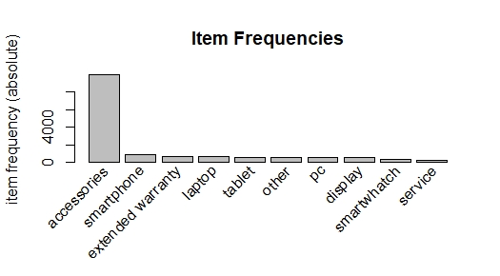

|  |  |
| --- | --- |
| product type | frequency |
| accessories | 9917 |
| smartphone | 899 |
| extended warranty | 712 |
| laptop | 690 |
| tablet | 629 |
| other | 606 |
| pc | 574 |
| display | 568 |
| smartwatch | 378 |
| service | 316 |
| camera | 248 |
| software | 237 |
| printer | 230 |
|  |  |

“Accessories” excluded, we can see that “Smartphones”, “Laptops” ,“Tablets” and “Extendend Warranty” are highly demanded by Electronidex customers.

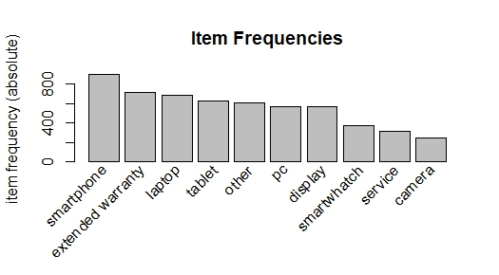

“Market Basket Analysis”, even on this very general level of just 11 product categories, can show us if customers regularly buy different kind of items combined.

If there is a clear pattern (“strong rules”) that we can infer out of this data, we will get a clearer picture of Electronidex customers and potential marketing strategies, in case of an acquisition of the company.

The following 10 “strong rules” show a clear buying pattern of Electronidex customers:

|  |  |  |  |  |  |  |  |
| --- | --- | --- | --- | --- | --- | --- | --- |
|  | **lhs** |  | **rhs** |  | **support** | **confidence** | **lift** |
| [1] | {extended warranty,software} | => | {pc} |  | 0.02018366 | 0.9859813 | 17.9 |
| [2] | {extended warranty,other} | => | {pc} |  | 0.02008800 | 0.9459459 | 17.2 |
| [3] | {software} | => | {pc} |  | 0.02085326 | 0.9198312 | 16.8 |
| [4] | {accessories,software} | => | {laptop} |  | 0.02066195 | 0.9686099 | 14.6 |
| [5] | {other,smartphone} | => | {extended | warranty} | 0.02008800 | 0.9767442 | 14.3 |
| [6] | {other,pc} | => | {extended | warranty} | 0.02008800 | 0.9722222 | 14.2 |
| [7] | {pc,software} | => | {extended | warranty} | 0.02018366 | 0.9678899 | 14.2 |
| [8] | {accessories,laptop,pc} | => | {extended | warranty} | 0.02008800 | 0.9677419 | 14.1 |
| [9] | {software} | => | {laptop} |  | 0.02114023 | 0.9324895 | 14.1 |
| [10] | {accessories,extended warranty,pc} | => | {laptop} |  | 0.02008800 | 0.9292035 | 14.0 |

For example, if someone buys a “Software” product and a “PC” at Electronidex, the probability that they will also purchase an “extended warranty” is 97 %. About 2 % of all purchases are made in this combination. And the high value of “lift” of 14.2 shows that there is a strong connection between these items and it isn’t just coincidental.

The insights we get out of these “strong rules” can be understood much better by visualisation.

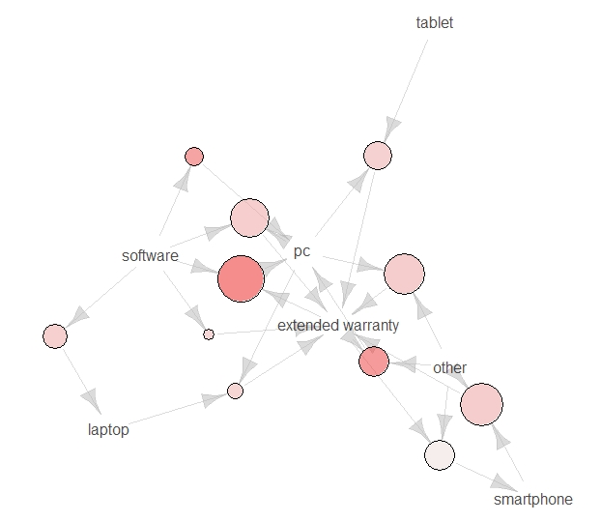

**

“Extended Warranty” has been purchased in combination with almost all product categories, especially with “Software” and “PCs”, but also “Tablets” or “Laptops”.

“Software” has been often bought in combination with “PCs” or “Laptops”.

In case that the acquisition takes place, market basket analysis has shown, that there is a lot of potentials for different marketing strategies.

A product recommendation system, that shows customers individually, what they can also buy, would boost revenues.

Cross marketing strategies, that offer “Extended warranties” in combination with “PCs” and “software” can also be very successful. We can bring in our experience in this field.

Customized e-mails with add-ons could also strengthen customer’s experience, when we already know what they want to buy at the end.

For a clearer understanding if Electronidex should be acquired, a comparison of the most successful product categories can be made with the data available, at least in regard to revenue.

**Revenue ELECTRONIDEX**

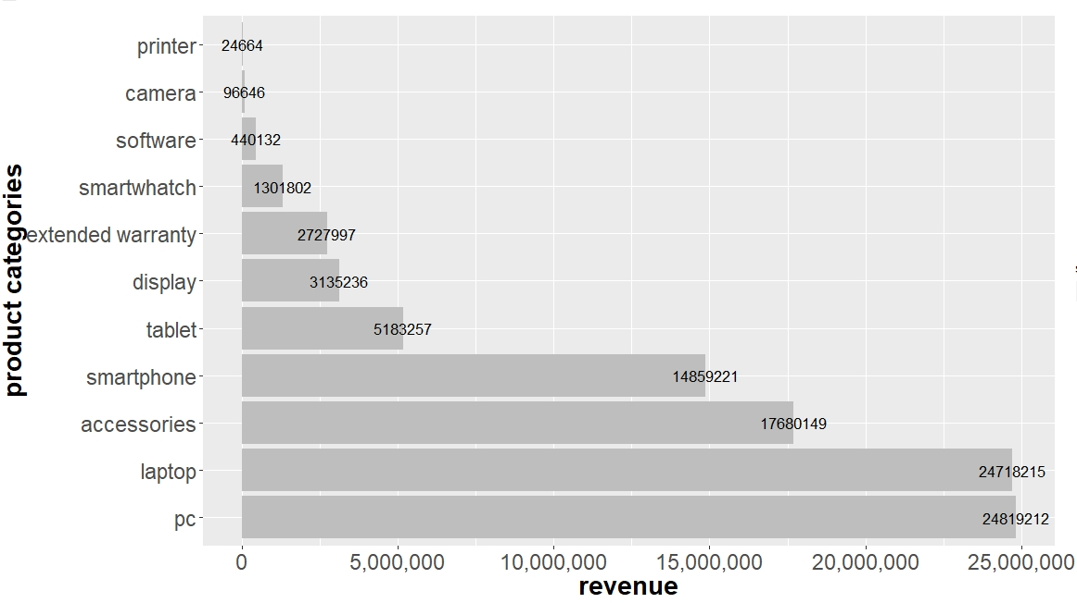

*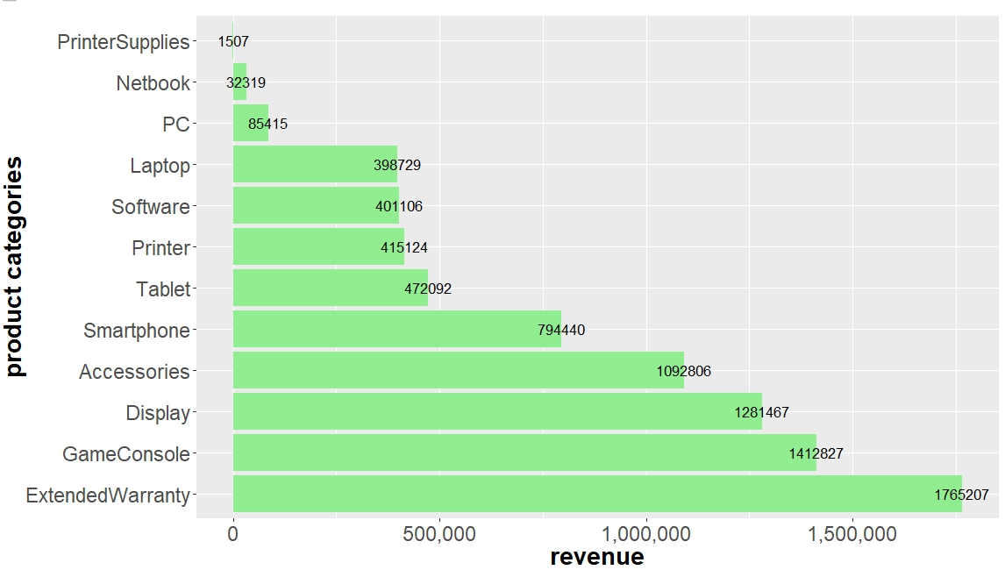***Revenue BLACKWELL ELETRONICS (unkown time frame!)**

The ranking of the product category revenues gives a clear indication how successful and important these categories are for both of these companies.

Here at Blackwell Electronics “Displays” and “Game Consoles” are adding a lot to the company’s revenue and “Extended Warranties” on products are very extensive. “Netbooks”, “PCs” and “Laptops” have a much lower revenue.

On the other hand, Electronidex is very successful in selling “PCs”, “Laptops” and “Accessories”.

**5. Conclusions and Recommendations**

Although the given data sets are very general, there are important insights about Electronidex’s customers.

Both companies seem to have different focus areas in their electronics product portfolio and therefore different strengths.

The product types and brands behind these categories are not apparent with the given data sets, however Electronidex seems to cover a broader spectrum and is more successful in important fields, like “PCs” and “Laptops”.

While Blackwell can make points where Electronidex seems to be in absence, like selling “Printers” or “Game Consoles”.

The product portfolios of both companies could complement each other well. On the basis of this very general information, we see a potential acquisition of Electronidex positive.

For a clear recommendation further analysis with more detailed data would be helpful.